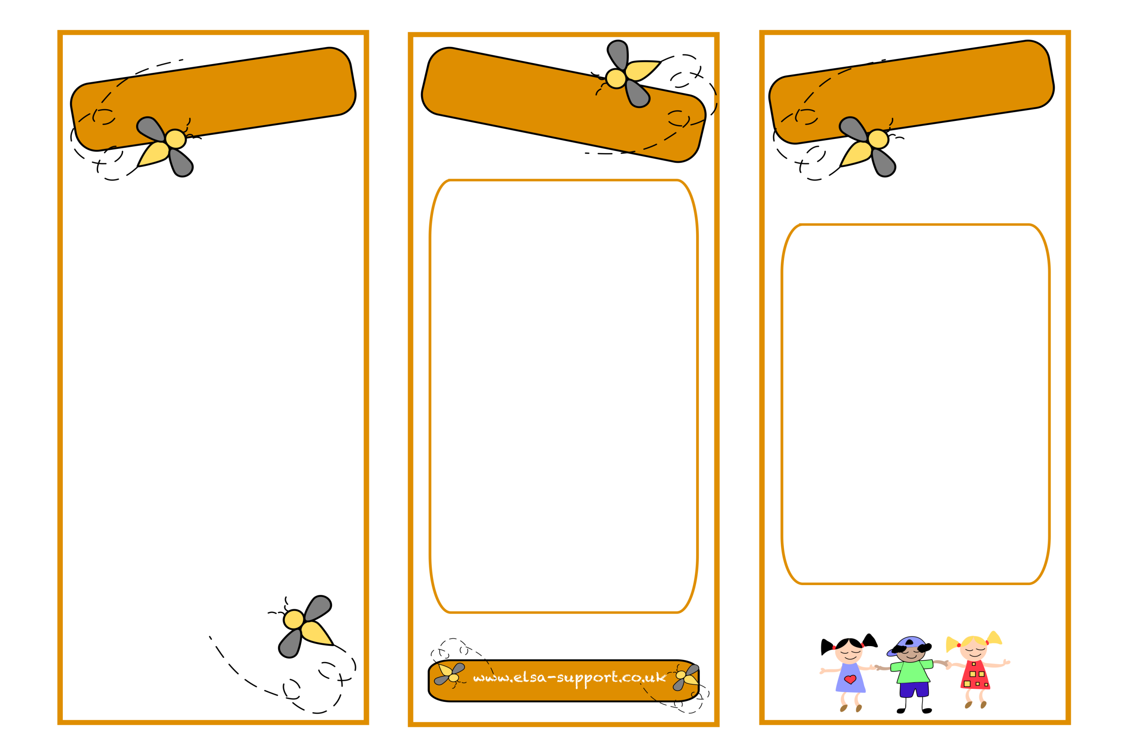
An Emotional Literacy Support Assistant (ELSA) is a specialist Teaching Assistant who works with children who are showing a range of emotional or social difficulties —for example, anxiety, shyness, low self- esteem, sadness, angry feelings or friendship problems.
ELSAs have been chosen because of their ability to build good relationships with children. They have completed formal training, working together with the Borough’s team of Educational Psychologists, An ELSA will plan a programme and work with a child, either individually or sometimes in a small group, using activities targeted to the child’s needs. Typically, ELSA work takes place over 6-12 weekly sessions.
ELSAs can help with:
Miss. George
Loss and bereavement
Self-esteem
Social skills
Emotions
Friendship issues
Relationships
Anger management
Behaviour
Anxiety
Bullying
Conflict
Relaxation techniques
Emotional
Literacy
Support
Assistant

ELSA
What is an ELSA
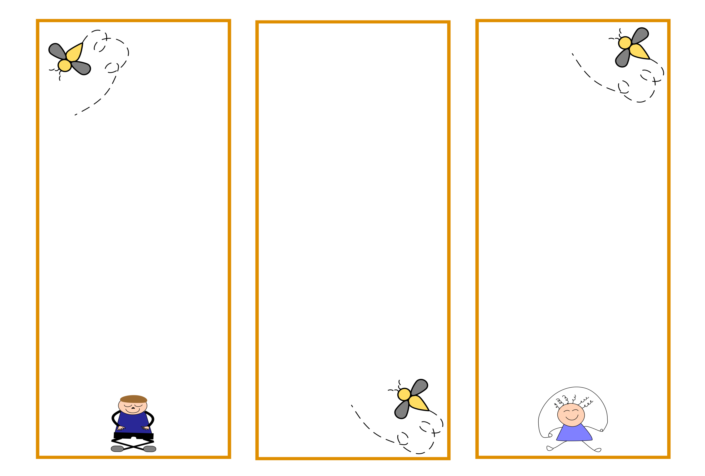
ELSAs are not there to fix children's problems. What they do is provide emotional support to those who need it.
They aim to establish a warm, respectful relationship with a pupil and to provide a reflective space where children are able to share honestly their thoughts and feelings.
ELSA sessions need to feel qualitatively different from school lessons. They are not about teaching pupils or telling them what to do, but about facilitating greater self-awareness in pupils and helping them to reach their own solutions and coping strategies.
The sessions will have an element of fun to them whether this is by playing games, asking questions or creating something arty!

Rest assured, ELSA sessions are treated with respect and the appropriate level of confidentiality whilst maintaining safeguarding and child protection procedures.
Your child’s progress will be carefully monitored during the ELSA programme and your child will be encouraged to use his or her new skills in class or in the playground.
If the school or parent feels the child needs further support, the class teacher and SENCO are available to discuss any next steps required.
As children grow-up they face many new things; each new thing can feel like a big step forward. You can help your children face new things without letting worry hold them back.
What you can do to support this:
• Spend time with your child. Do things you both enjoy. Go for a walk, cook, eat, play or just hang out. Find ways to laugh and smile together; this creates moments for children to open up naturally.
• Listen with patience. Give them time to put their thoughts and feelings into words.
• Validate. Let your child know you understand and that its ok to feel how they feel. Listen calmly and accept how they feel, this makes it easier for them to share. procedures. Your child’s progress will be carefully
• Encourage/Help them practise. When possible, help your child break a new thing into small steps. Let them practise one step at the time as they build toward their goal. Praise your child’s effort and progress rather than the end result.

What if my child needs more help?
Group session
Individual session

